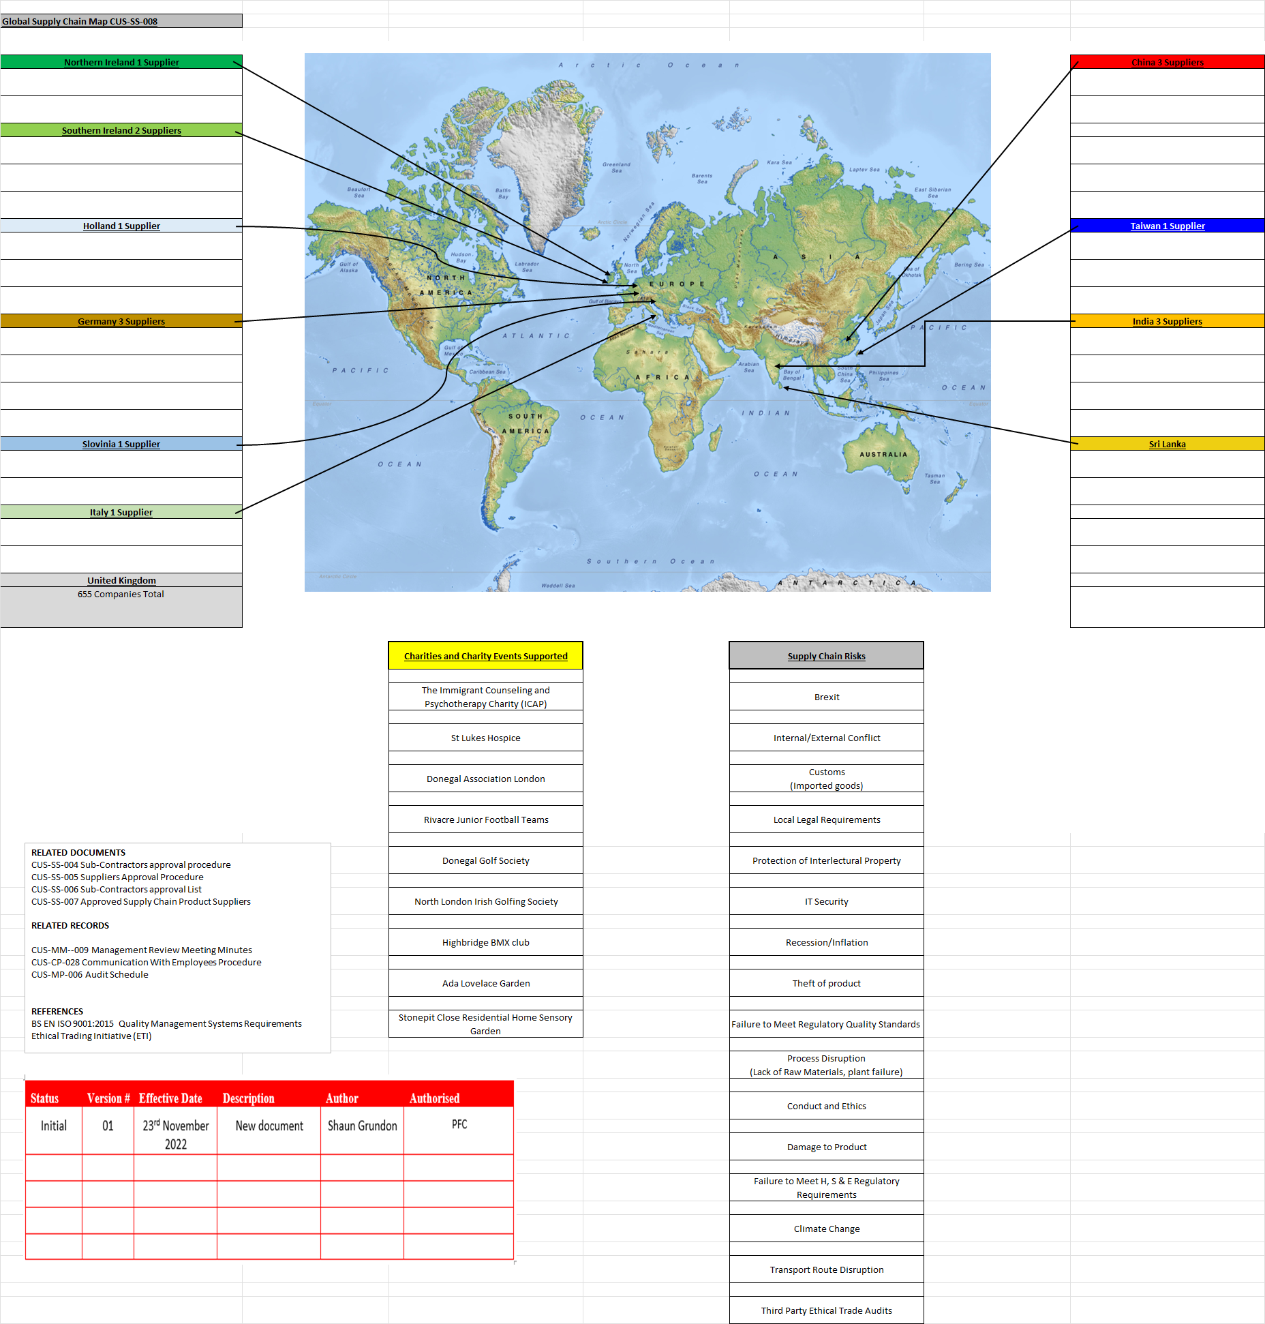

P F Cusack (Tool Supplies) Ltd procure goods and services form both UK based and overseas suppliers. On completing our supply chain mapping and supplier assessments we as a company took the decision to change our methodology and approach to our supply chain allowing us to look at all of our suppliers in more depth. The focus of our new supply chain mapping programme is one of building closer long term relationships with our suppliers with a far more approachable style encouraging information exchange. At the moment we are currently working with our tier 1 suppliers but at the same time with our new recycling services encouraging our tier 2 suppliers to actively communicate with us.

Supply chain transparency

It is not P F Cusack (Tool Supplies) Ltd.’s policy to share any information regarding its suppliers with any third parties.

We are suppliers of Personal Protective Equipment, Respiratory Protective Equipment and Corporate Clothing and supply these products to several different industries As such many of our Personal Protective Equipment products are bespoke to us and are our intellectual property. In line with this several of our clients have contracts to supply bespoke Personal Protective Equipment and we are contractually obliged not to share this information with any third parties.

In light of this going forward we are looking at our list of approved suppliers with the aim of producing a list of 1st tier suppliers who supply our Personal Protective Equipment and Respiratory Protective products to us that would not affect our intellectual property and are also less commercially sensitive to both us and our clients as many of the contracts with our clients are long term 3 to 5 years and in a number of cases are less than 2 years in. Where possible we will open a dialogue with the clients who we are contracted to supply to seek approval to share information but in many cases is unlikely to gain approval until contract renewal. This would be done with the aim of sharing a partial list of our tier 1 suppliers confidentially and privately with ETI by the end of December 2025.

A more detailed assessment of the risks associated with our supply chain can be found under 1.6 salient risks

Pages 2 and 4 of our modern slavery statement